NAME:SHIVATHMIKA V
REG NO: 192521028
SUBJECT: CSA1204 COMPUTER ARCHITECTURE
CO3AT1
Design and simulate a system that performs register transfer operations along with basic arithmetic and logic operations such as addition, subtraction, AND, and OR. Use multiple registers to demonstrate how data is transferred between them during execution, and analyze the sequence of operations and the role of the ALU in processing data.

Aim
To design and simulate register transfer operations and basic arithmetic and logical operations using multiple registers and an ALU.

Objective
The system demonstrates:

  - Register-to-register data transfer
  - Addition
  - Subtraction
  - AND
  - OR
  - Role of ALU
  - Sequence of operations

Python Implementation
# Q1 - Register Transfer and ALU Simulation

class CPU:

def init (self): s elf.registers = {
"R1": 0,

"R2": 0,

"R3": 0,

"R4": 0

}

def transfer(self, source, destination): self.registers[destination] = self.registers[source] print(f"Transfer: {source} -> {destination}") self.display()

def alu(self, operation, source1, source2, destination):

a = self.registers[source1]

b = self.registers[source2]

if operation == "ADD": result = a + b
elif operation == "SUB": result = a - b
elif operation == "AND": result = a & b
elif operation == "OR": result = a | b
else:

print("Invalid operation") return

self.registers[destination] = result

print(f"ALU: {source1} {operation} {source2} -> {destination}") print(f"Calculation: {a} {operation} {b} = {result}") self.display()

def display(self): print("Registers:", self.registers) print("-" * 40)

cpu = CPU()

print("INITIAL REGISTERS")

cpu.display()

# Load values cpu.registers["R1"] = 20
cpu.registers["R2"] = 10

print("After loading R1=20 and R2=10") cpu.display()

# Register transfer cpu.transfer("R1", "R3")

# Arithmetic operations cpu.alu("ADD", "R1", "R2", "R3")
cpu.alu("SUB", "R1", "R2", "R4")

# Logical operations cpu.alu("AND", "R1", "R2", "R3")
cpu.alu("OR", "R1", "R2", "R4")

Output

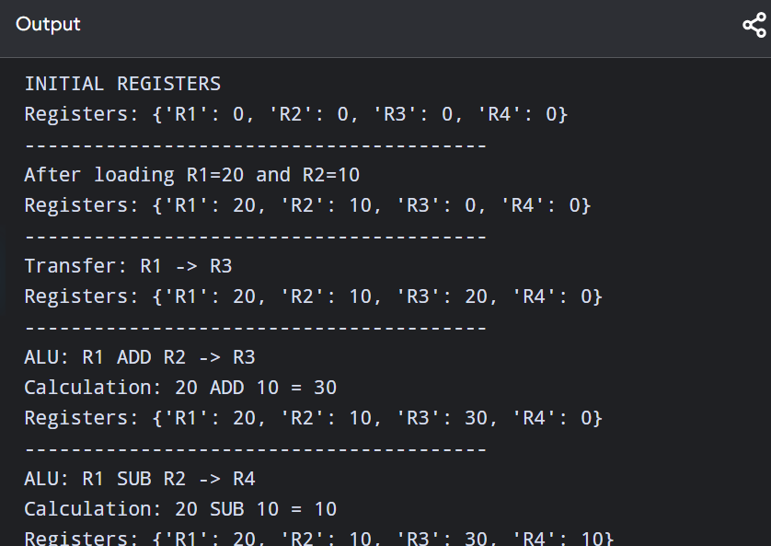

Create a model of a computer system using single-bus and multi-bus organization, and perform data transfer operations between registers, memory, and I/O. Compare the time taken and efficiency of both approaches, and analyze how multiple bus structures improve parallel data transfer and reduce bottlenecks.

1. Aim

To model single-bus and multi-bus computer organization and compare their data transfer efficiency.

Single-Bus Organization
In a single-bus system, all components share one common bus. R1 ──┐
R2 ──┤
R3 ──┤──► SINGLE BUS ──► ALU R4 ──┤
MEM ─┘

Only one major transfer can use the bus at a time.

Example

For:

R3 = R1 + R2

The processor needs:

R1 → Bus Bus → ALU R2 → Bus Bus → ALU ALU → R3

This creates more transfer steps.

Multi-Bus Organization

A multi-bus system can transfer multiple operands simultaneously.

┌──────────┐ R1 ─────────►│ │
│ Bus A │
│ │
└────┬─────┘
│
▼
┌─────┐
│ ALU │
└─────┘
▲
│
┌────┴─────┐
R2 ─────────►│ Bus B │
└──────────┘

R1 and R2 can be supplied to the ALU at the same time.

Python Simulation
# Q2 - Single Bus vs Multi Bus

def single_bus_operation():

print("\nSINGLE BUS ORGANIZATION")

print("-" * 40)

cycles = 0
print("1. R1 -> Bus") cycles += 1

print("2. Bus -> ALU") cycles += 1
print("3. R2 -> Bus") cycles += 1
print("4. Bus -> ALU") cycles += 1
print("5. ALU -> R3")

cycles += 1

print("Total cycles:", cycles)
return cycles

def multi_bus_operation():

print("\nMULTI BUS ORGANIZATION")

print("-" * 40)

cycles = 0
print("1. R1 -> Bus A and R2 -> Bus B") cycles += 1
print("2. ALU performs R1 + R2") cycles += 1
print("3. ALU -> R3")

cycles += 1
print("Total cycles:", cycles)
return cycles
single = single_bus_operation() multi = multi_bus_operation()

improvement = ((single - multi) / single) * 100

print("\nCOMPARISON") print("-" * 40)
print("Single Bus cycles:", single) print("Multi Bus cycles :", multi)
print(f"Efficiency improvement: {improvement:.2f}%")

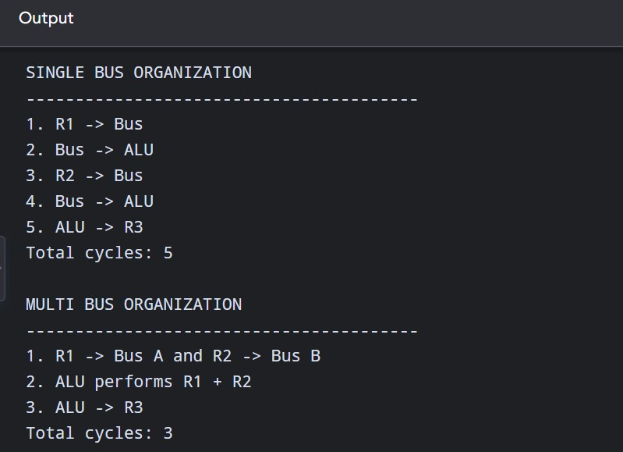
Simulate a 5-stage instruction pipeline (Fetch, Decode, Execute, Memory, Write-back) and execute a set of instructions. Measure the performance in terms of speedup and throughput, and compare it with a non-pipelined system to evaluate the effectiveness of pipelining.

Aim
To simulate a 5-stage instruction pipeline and compare its performance with a non-pipelined processor.

Five Stages
IF → ID → EX → MEM → WB

Where:

Stage | Meaning
IF | Instruction Fetch
ID | Instruction Decode
EX | Execute
MEM | Memory Access
WB | Write Back

Pipeline Diagram
For five instructions:
Cycle → 1 2 3 4 5 6 7 8 9 I1 IF ID EX MEM WB
I2 IF ID EX MEM WB
I3 IF ID EX MEM WB
I4 IF ID EX MEM WB
I5 IF ID EX MEM WB

The important point is that multiple instructions are being processed simultaneously in different stages

Python Implementation
# Q3 - Five Stage Pipeline Simulation instructions = [
"I1: ADD R1,R2,R3",
"I2: SUB R4,R5,R6",
"I3: AND R7,R8,R9",
"I4: OR R10,R11,R12", "I5: ADD R13,R14,R15"
]

stages = ["IF", "ID", "EX", "MEM", "WB"]

n = len(instructions)

print("5-STAGE PIPELINE")
print("=" * 70)

print("Cycle\t" +
"\t".join(instructions)) for cycle in range(1, n + len(stages)):
row = []

for i in range(n): stage_index = cycle - i - 1

if 0 <= stage_index < len(stages): row.append(stages[stage_index])
else:
row.append("-") print(f"{cycle}\t" + "\t".join(row))

# Performance calculation

non_pipeline_cycles = n * len(stages) pipeline_cycles = n + len(stages) - 1

speedup = non_pipeline_cycles / pipeline_cycles

throughput_non_pipeline = n / non_pipeline_cycles throughput_pipeline = n / pipeline_cycles

print("\nPERFORMANCE") print("=" * 40)

print("Instructions:", n)
print("Non-pipelined cycles:", non_pipeline_cycles) print("Pipelined cycles:", pipeline_cycles) print(f"Speedup: {speedup:.2f}x")
print(f"Non-pipelined throughput: {throughput_non_pipeline:.3f}") print(f"Pipelined throughput: {throughput_pipeline:.3f}")

output

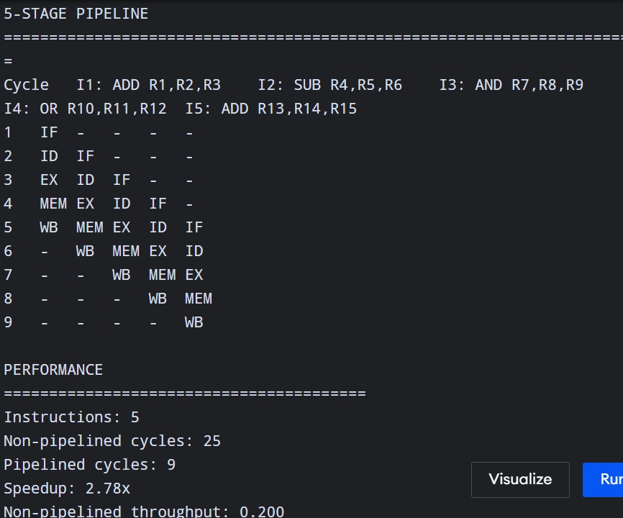

Develop a pipeline execution scenario where data hazards, control hazards, and structural hazards occur. Observe their impact on instruction execution, and implement techniques such as stalling, data forwarding, and branch prediction to resolve these hazards and improve performance.

1. Aim
To simulate data, control and structural hazards and demonstrate techniques such as stalling, forwarding and branch prediction.

Types of Hazards
- Data Hazard
Occurs when one instruction depends on the result of a previous instruction. Example:
I1: ADD R1,R2,R3 I2: SUB R4,R1,R5

I2 needs R1, but I1 has not completed writing R1
I1 → produces R1
↓
I2 → needs R1

Control Hazard

Occurs because of branch instructions. Example:
I1: ADD R1,R2,R3
I2: BEQ R1,R0,LABEL I3: SUB R4,R5,R6

The processor does not immediately know whether I3 should execute.

Structural Hazard

Occurs when two instructions need the same hardware resource simultaneously. Example:
Instruction 1 → Memory Instruction 2 → Memory

If only one memory unit exists, they compete for the resource.

Hazard Handling
Data hazard → Forwarding
EX result
│
└────────► next instruction

Instead of waiting for the result to be written to the register.

Control hazard → Branch Prediction

Processor predicts:

Branch Taken or:
Branch Not Taken
Structural hazard → Stalling
One instruction waits until the resource becomes available.

Python Simulation

# Q4 - Pipeline Hazard Simulation

instructions = [

("I1", "ADD R1,R2,R3"),

("I2", "SUB R4,R1,R5"), # Data dependency ("I3", "BEQ R4,R0,L1"), # Control hazard ("I4", "LOAD R6,0(R7)"), # Structural resource ("I5", "LOAD R8,4(R7)")

or thread2: cycle += 1 print(f"\nCycle {cycle}")
if thread1:
instruction = thread1.popleft() print("Thread 1 executes:", instruction)
if thread2:
instruction = thread2.popleft() print("Thread 2 executes:", instruction)

print("\nBoth threads completed.")

